|  |  |
| --- | --- |
|  | |
|  | |
|  |  |

|  |  |
| --- | --- |
| Publication type: |  |
| Publication number: | ACC |
| Title: |  |
| Subject: |  |
| Issue: | 2.1.3 |
| Publication date: | 22 October 2014 |
| Total number of pages: |  |
| Author: |  |
| Quality Control: |  |

Table of contents

Page #

Figures 3

Tables 4

References 6

Introduction 7

About the Installation Manual 7

Safety instructions 9

Revision history 9

1. Setting and adjustment 10

1.1 Detection of new devices 10

1.2 Preparatory work 10

1.3 Using the Moxa-updater 10

1.4 Detection of installed serial devices 11

1.4.1 Installation of software 13

2. Extra functionality 14

2.1 Introduction 14

2.1.1 Connection 14

2.1.2 Firewall configurator (Device Settings) 14

2.1.2.1 LAN 1 IP Settings (I/O side ) 14

2.1.2.2 LAN 2 IP Settings (Cloud side) 15

2.1.3 Firewall configurator (Forwarding) 15

2.1.3.1 Forwarding functions 17

2.1.3.2 Saving and updating 20

2.1.4 Modbus TCP server or True Wind 20

2.1.5 Actions: Login 20

3. Remote access 21

4. Technical specifications 24

Figures

Figure 1‑1: Serial config screen 11

Figure 1‑2: Software updater screen 12

Figure 1‑3: Update Version 13

Figure 2‑1: Device Settings 14

Figure 2‑2: Forwarding 16

Figure 2‑3: Trashcan 16

Figure 2‑4: Forwarding choice 17

Figure 2‑5: Link sign 17

Figure 2‑6: Visualization port forwarding Inside out 17

Figure 2‑7: Visualization port forwarding Outside in 17

Figure 2‑8: Forwarding settings 19

Figure 2‑9: Moxa Telnet session 20

Figure 3‑1: boot loader window 21

Figure 3‑2: Adjustment window 21

Figure 3‑3: Adjustments for remote access 22

Figure 3‑4: Boot.uc.ini 23

# Tables

Table 1: Software updater columns 12

Table 2: Software Updater Colors 12

Table 3: Software Updater Colors 2 13

Table 4: LAN 1 IP settings 15

Table 5: LAN 2 IP settings 15

Table 6: Forwarding choices 17

**NOTICE**

**This document contains proprietary information.**

**No part of this document may be photocopied, reproduced or translated into another language without the prior written consent of   
Imtech B.V.**

References

Moxa:

[www.Moxa.com](http://www.moxa.com)

Introduction

The Installation manual provides instructions for setting and adjusting the serial interface as used within NavVision. The chapters and sections are organized in chronological order in which the specific components must be installed and monitored (where applicable).

About the Installation Manual

This manual contains the following sections:

* Chapter “Safety instructions” presents warning, caution and note information, which the user should pay attention to.
* Chapter “Setting and adjustment” gives an instruction on how to set and adjust the serial interface.
* Chapter “Technical specifications” contains an overview of the main features and technical data

. *For specific information on interfaces, but also in depth information on here mentioned features, as well as here not mentioned features, we refer you to the specific manuals from NavVision that can be obtained through Imtech.*Abbreviations list

DHCP Dynamic Host Configuration Protocol

FT Free Technics

IP Internet Protocol

LAN Local Area Network

MAC Media Access Control

N/A Not Applicable

Safety instructions

* This section provides only a summary of the safety requirements and notes in the following sections. To protect your health and prevent damage to the AM(C)S equipment or vessel, it is essential to read and carefully follow the safety instructions.*

The indications NOTE, CAUTION and WARNING have the following significance:

* NOTE:  
An operating procedure, practice or condition etc., which it is important to emphasize.*

* CAUTION:*

*An operating procedure, practise or condition etc., which, if not strictly observed, may damage AM(C)S equipment or crash NavVision software.*

* WARNING:*

*An operating procedure, practise or condition etc., which, if not carefully observed may result in personal injury or damage to the vessel.*

Revision history

Revisions issued since publication.

|  |  |  |  |
| --- | --- | --- | --- |
| **Issue** | **Date** | **Revision** | **Reason** |
| 2.1.1 | September 22, 2014 | New version | Initial new version |
| 2.1.2 | October 24, 2014 | Adjustments | Minor fixes |
| 2.1.3 | October 27, 2014 | Small adjustments for Michel | Explanation |

# Setting and adjustment

## Detection of new devices

It is quite difficult to detect new Moxa devices on the network because of the following, standard IP-address settings:

* LAN 1: 192.168.3.127 / 255.255.255.0
* LAN 2: 192.168.4.127 / 255.255.255.0

If the Moxa is set to a new, not standard, IP-address it will be even harder to reach it. In order to reach the Moxa serial device, at least one of the two IP addresses and netmasks must be known. In case that you don’t know the exact IP-address it is best to reset the device by press and hold the reset button for 10 seconds. After that the IP-addresses will be set back to the standard addresses.

*:If you reset the device, also all the programs that are in the device will be gone. Make sure that you have backups available.*

## Preparatory work

To make sure that your PC can connect to the Moxa, you have to change the IP settings of the LAN-port that you use to connect to the Moxa network. If the IP-addresses of the Moxa are standard, you need to change your port settings to that IP range (i.e. 192.168.3.78) with a subnet mask of 255.255.255.0 or if you know the new IP-address of the Moxa, you need to set it in that range.

## Using the Moxa-updater

Start the Moxa Updater (latest version 10.0.00.100). If there is connection to the right IP-address on the Moxa, it will show the “Software updater screen” (see Figure 1‑2).

If the software does not connect to the serial device within 10 seconds, a “Serial config(uration)” screen will be shown. This screen can also be shown by means of the “Serial configure” button (Figure 1‑1). Via the “Serial config“ screen the PC’s serial port can be selected which is necessary to configure the serial device.

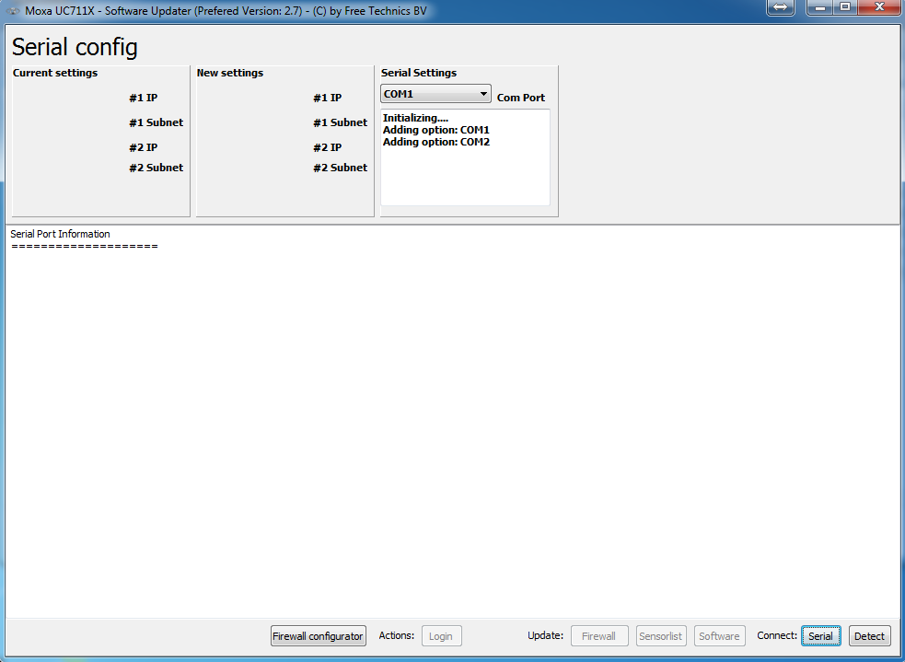

Figure 1‑1: Serial config screen

## Detection of installed serial devices

The detected serial device is shown on the screen below. All present and detected serial devices are shown on this screen.

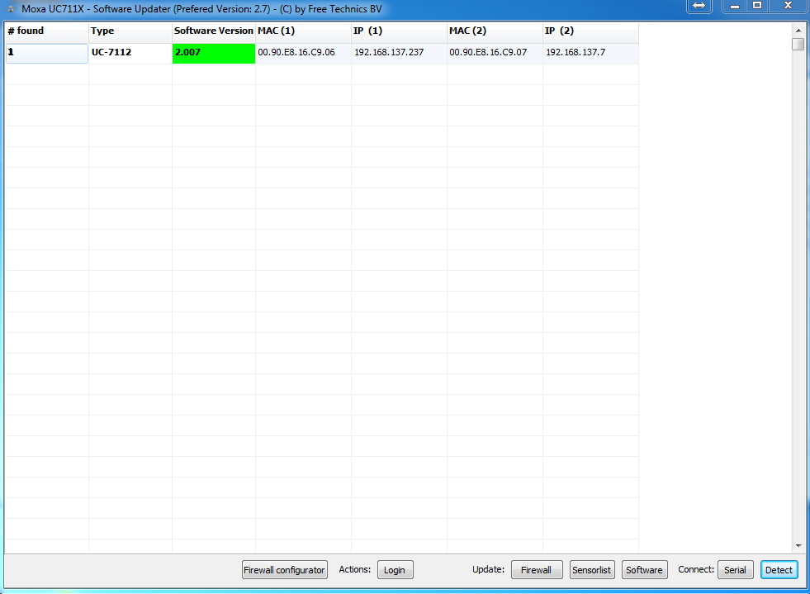

Figure 1‑2: Software updater screen

|  |  |
| --- | --- |
| **Column** | **Description** |
| # found | The number of found Moxa’s |
| Type | The type of Moxa (UC-7112, UC-7110 or Unknown Device) |
| Software Version | The version number of the software installed (Number or N/A) |
| MAC (1) | The MAC address of lan 1 |
| IP (1) | The IP address of lan 1 |
| MAC (2) | The MAC address of lan 2 |
| IP (2) | The IP address of lan 2 |

Table 1: Software updater columns

|  |  |
| --- | --- |
| **Colour** | **Description** |
| Red | Software as used is obsolete and can be updated. |
| Green | Moxa software version is identical to software updater version. No update of software necessary. |
| Purple | Moxa software version is newer than software updater version. Software updater version is probably obsolete.  DO NOT UPDATE SOFTWARE!!! |

Table 2: Software Updater Colors

### Installation of software

When installing the (new) Moxa software ensure that the relevant serial device is selected from the list (you will find the latest releases on the server of Imtech).

Select the “Software” button in the update section (see Figure 1‑2) to load the device software (at this moment the software version should be 2.7 ). Press “OK” (see Figure 1‑3).

Once the software is fully loaded the Moxa serial device including software will automatically restart. Once the software has been successfully updated, the software updater will show the latest device software number.

|  |  |
| --- | --- |
| **Colour** | **Description** |
| Green | IP-address is configured for the same subnet and the selected PC network interface. This indicates that a direct connection is possible (only when cabling is ok) |
| Grey | IP-address is configured for a different subnet than the selected PC network interface. Most likely the subnet mask is not identical. |

Table 3: Software Updater Colors 2

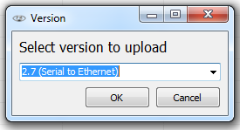

Figure 1‑3: Update Version

*:NavVision will configure the Moxa automatically concerning the IP-addresses. For more information we refer to the “commissioning and installation manual” Chapter 11.9.3.2*

# Extra functionality

## Introduction

The Moxa is capable to store some extra intelligence.

For example Firewall, IP-forwarding or Ipod connection. It is also possible to reserve a port for remote access.

### Connection

After you’ve updated the standard firmware to version 2.7 you can now add some extra functionality..

Connect your laptop to the same Lan-network and make sure that it is in the same IP range (this should already be the case when you just have updated the standard version)

Open the Moxa updater.

### Firewall configurator (Device Settings)

At the bottom of the screen you will find the button “Firewall Configurator” (see Figure 1‑2). Click it to open the configurator. Another screen will appear (see Figure 2‑1).

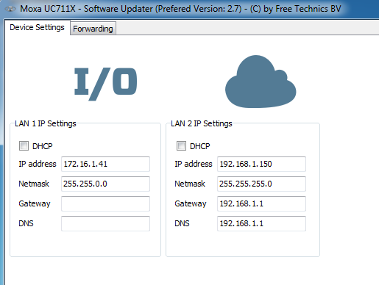

Figure 2‑1: Device Settings

#### LAN 1 IP Settings (I/O side )

In the section “LAN 1 IP Settings” you can change all the settings for the first LAN port of the Moxa. You can choose the following options:

|  |  |
| --- | --- |
| **Column** | **Description** |
| DHCP | Select if you want the network address to be set automatically |
| IP Address | Set the desired IP address |
| Netmask | Set the Netmask |
| Gateway | Set the Gateway |
| DNS | Set the Dynamic Name Server IP |

Table 4: LAN 1 IP settings

At the “LAN 1 IP Settings” you will set the IP-range that the Moxa needs for connection to the NavVision network. For instance you have a Moxa which has got the address 172.16.1.41. You will set this address as IP address for LAN 1. Make sure that you use the right Netmask. Supplementary you can set a gateway and DNS when applicable.

#### LAN 2 IP Settings (Cloud side)

In the section “LAN 2 IP Settings” you can change all the settings for the second LAN port of the Moxa. You can choose the following options:

|  |  |
| --- | --- |
| **Column** | **Description** |
| DHCP | Select if you want the network address to be set automatically |
| IP Address | Set the desired IP address |
| Netmask | Set the Netmask |
| Gateway | Set the Gateway |
| DNS | Set the Dynamic Name Server IP |

Table 5: LAN 2 IP settings

At the “LAN 2 IP Settings” you will set the IP-range that the Moxa needs for connection to the Ships (external) network. For instance you have a Moxa which connects to the ships network at 192.168.1.150 You will set this address as IP address for LAN 2. Make sure that you use the right Netmask. Supplementary you can set a gateway and DNS when applicable.

When set to DHCP the LAN 2 port will ask for an address from the DHCP server.

*: The interface that needs to connect from the outside to Modbus or iPod has to connect to the IP address that you gave to the LAN 2 port of the Moxa. The program will forward it to the right IP address internally.*

### Firewall configurator (Forwarding)

Switching to the tab “Forwarding” brings you to a new window (see Figure 2‑2) where you can set multiple forwarding rules.

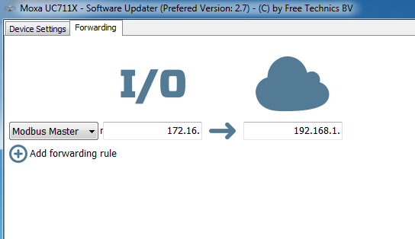

Figure 2‑2: Forwarding

As you can see in Figure 2‑2 the first forwarding rule is already been set. These are the IP-ranges that you set under “Device Settings” taken the Netmask in account.

*: If the first forwarding rule is not the right one, it might be the reason that there was already a rule set before. You need to remove all the rules in the forwarding-window and add a new one. Now this will be the right one.*

By hovering with your mouse at the end of a forwarding rule, a trashcan will appear (see Figure 2‑3). By clicking on the trashcan, you delete the rule.

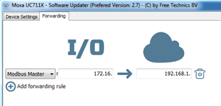

Figure 2‑3: Trashcan

By clicking at the Plus-sign, you can add a new rule.

By clicking at the drop-down-menu at the beginning of a rule, you can choose which forwarding you need (see Figure 2‑4).

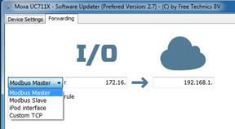

Figure 2‑4: Forwarding choice

You can choose the following:

|  |  |
| --- | --- |
| **Choice** | **Description** |
| Modbus Master | Select if NavVision is the Modbus Master |
| Modbus Slave | Select if NavVision is the Modbus Slave |
| iPod Interface | Select if you need to connect to NavVision with iPod/iPad |
| Custom TCP | Custom forwarding settings |

Table 6: Forwarding choices

When an address is reachable by Ping, the link-sign will appear (see Figure 2‑5).



Figure 2‑5: Link sign

#### Forwarding functions

The best way to describe the port forwarding is by looking at the next two figures (see Figure 2‑6 and Figure 2‑7). You will notice that it can go from inside out (Figure 2‑6) and from outside in (Figure 2‑7).

Virtual External

  

Figure 2‑6: Visualization port forwarding Inside out

NavVision Virtual

  

Figure 2‑7: Visualization port forwarding Outside in

If you go from inside out (which will be used when NavVision is the Modbus Master), the I/O-side is the virtual port.

If you go from Outside in (Which will be used when NavVision is Modbus Slave or when you want to connect an iPod/iPad to NavVision), the Cloud-side is the virtual port.

So in order to connect these through the “Firewall Configurator” The following rules apply:

NavVision is Modbus Master

* Assign a virtual IP address to the I/O side.
* Assign the given Modbus slave IP address to the Cloud side.
* When NavVision as Master, sends questions to the Slave The Moxa will translate the IP address to the external Modbus Slave IP address at the Cloud Side.
* Answers from the cloud side IP address will be re-routed back to the I/O side IP address.

NavVision is Modbus Slave

* Assign IP address of the Modbus slave (i.e. the server where NavVision is running. Make sure you do this for every server available for redundancy) to the I/O side.
* Assign a virtual IP address to the Cloud side where the Modbus master can connect to (set this address in the external Modbus Master).
* Let the external Modbus master connect to the IP address at the Cloud Side
* The cloud side IP address will be forwarded to the I/O side IP address.

Connect iPod interface

* Assign IP address (i.e. the server where NavVision is running. Make sure you do this for every server available for redundancy) to the I/O side.
* Assign a virtual IP address to the Cloud side (set this address in the iPod/iPad).
* Let the iPod/iPad connect to the IP address at the Cloud Side
* The cloud side IP address will be forwarded to the I/O side IP address.

When you look at the forwarding settings, it will look as in Figure 2‑8.

As an example let’s say that NavVision is Modbus Master for a Deif-system. The Deif has an IP address of 192.168.1.100 while NavVision has an IP range of 172.16.x.y. It is impossible to connect the Modbus master directly to the Deif system because that would give an IP-conflict.

So we put a Moxa in between. Now we must show the Modbus master (NavVision) where it will need to connect to. In this case it is the Deif’s IP address (192.168.1.100). Because it is out of IP-range, NavVision cannot connect directly. To make clear to NavVision that it will have to be rerouted to another IP-range, we need to setup a virtual IP address where it can connect to. In this case we choose for 172.16.1.150 (it doesn’t matter which IP address you choose, as long as it is not in use already).

So, at the Cloud-Side we fill in the actual IP address of the Deif (192.168.1.100) and at the I/O-Side we fill in the made-up IP address that we use to reroute the NavVision side to the Deif side (172.16.1.150).

When NavVision starts communicating to the Deif it will direct its communication to the Deif IP address (192.168.1.100) the Moxa will recognize that the communication from the NavVision side will have to be routed to the external side. So a question from NavVision as master will get into the Moxa at 172.16.1.150 and will be forwarded to the external side at 172.16.1.100.

When the Deif is answering, the Moxa will reroute these answers back from 192.168.1.100 to 172.16.1.150, where it can be read by NavVision.

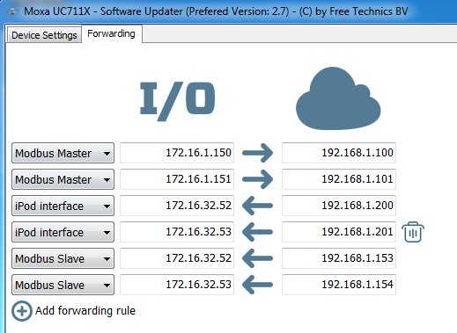

Figure 2‑8: Forwarding settings

#### Saving and updating

Once you are done with the forwarding you need to save the configuration. To do that, press the “Save File” button. Once saved, press the “Firewall” button under the update section (see Figure 1‑2).

The Moxa will be updated and restarted from here. After restart the Moxa will be up to date.

*: If you want to load an existing rc.custom-file, you can use the “Load File” in the updater to load the rc.custom from the Moxa.*

### Modbus TCP server or True Wind

If you need to use the “Modbus TCP server” or the “True wind” You only need to transfer the Moxa_sensorlist.tsv-file to the appropriate folder on the Moxa. The Moxa will scan for a .tsv file every second. Once found it will create two .DAT files and rename the Moxa_sensorlist.tsv-file.

You can use the “Sensorlist” button in the update section to upload the sensorlist to the right folder (see Figure 1‑2).

### Actions: Login

If you need to log in to the actual Moxa, you can press the “Login” button under the Actions section (see Figure 1‑2). This will open a Telnet session with the Moxa (see Figure 2‑9).

For information on how to work with this, we refer to “Moxa Linux for Dummies”.

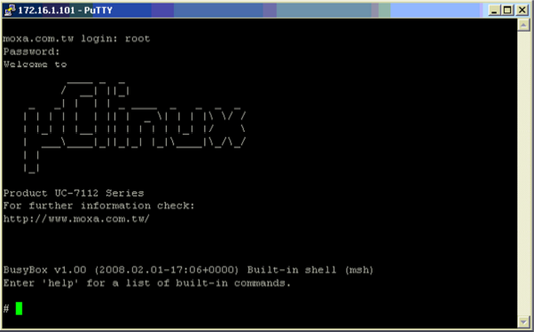

Figure 2‑9: Moxa Telnet session

# Remote access

If the Moxa is used for remote access there has to be some things changed within NavVision.

First you will have to go to the boot loader and open the Adjustment window. For those not familiar with this, the boot loader is the shell where NavVision is running on. Once you close all the viewers of the program, you will see a background like in next picture:

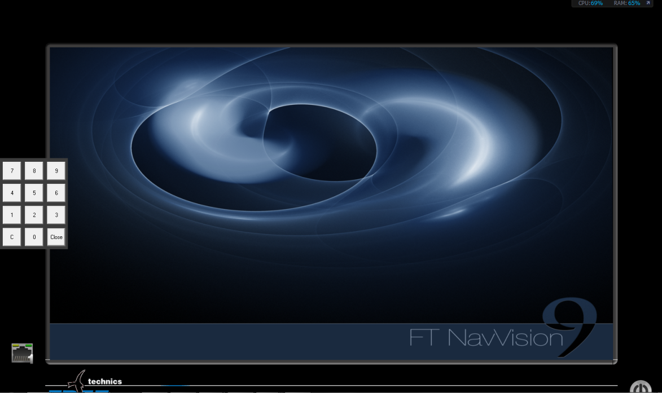

Figure 3‑1: boot loader window

By clicking and holding the left mouse button, while dragging from left to right, the num-pad will appear. The standard code is “0000”. The adjustment window will appear.

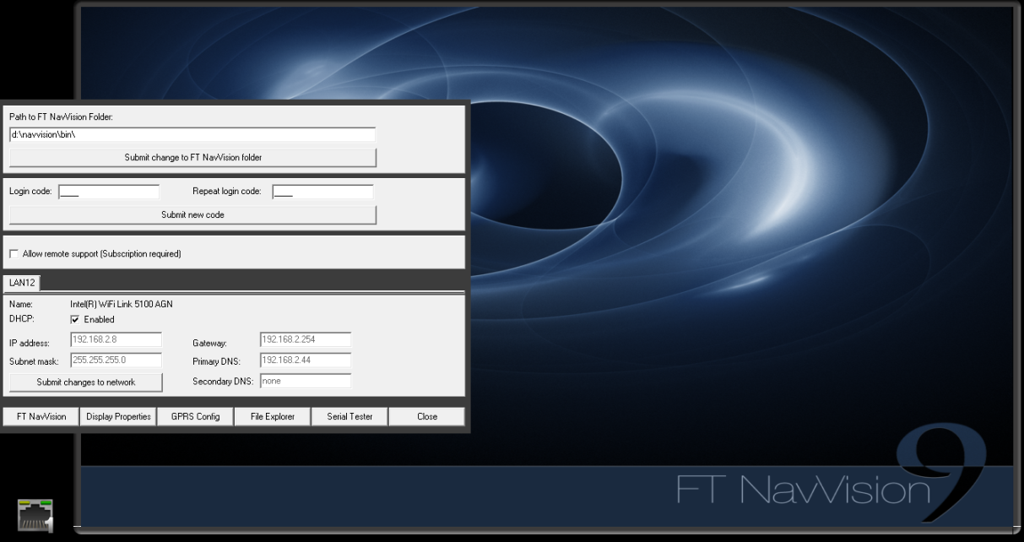

Figure 3‑2: Adjustment window

In this windows you need to make the following adjustments:

Put a checkmark at “allow remote support”

Put the IP-address of the Moxa in the fields “Gateway” and “Primary DNS”

(see Figure 3‑3)

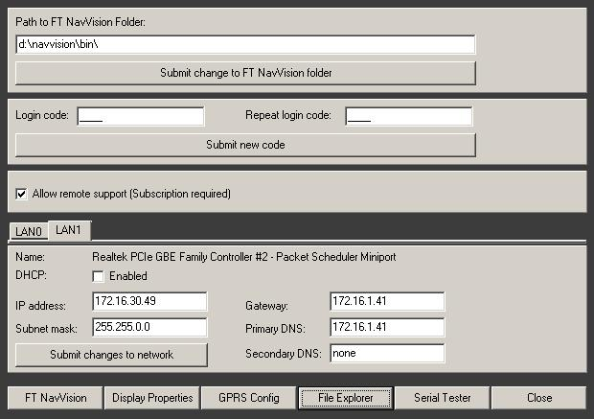

Figure 3‑3: Adjustments for remote access

By clicking on the “File Explorer” tab, you will get into the normal windows environment.

Goto D:\NavVision\config\local and open the boot.uc.ini file (see Figure 3‑4)

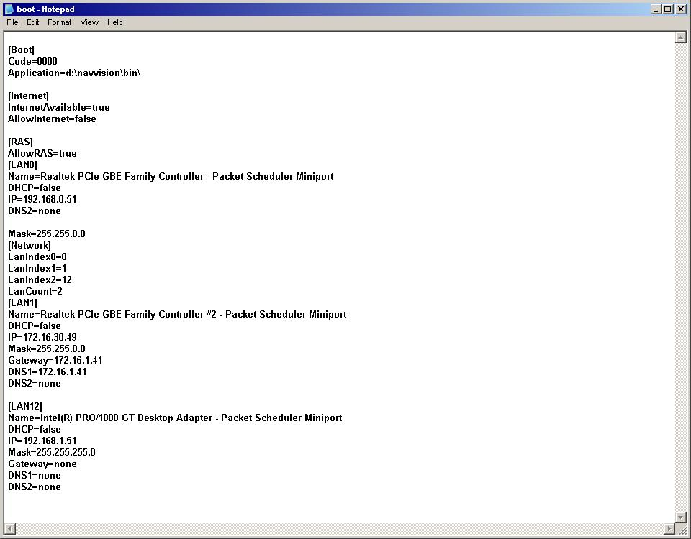

Figure 3‑4: Boot.uc.ini

Under [Internet], change “InternetAvailable=auto” into “InternetAvailable=true”

Close the file and save it (overwrite if necessary). Reboot the system and the remote access is ready.

# Technical specifications

|  |  |
| --- | --- |
| **Detail** | **Description** |
| CPU | ARM9-based 32-bit RISC CPU, 166 Mhz |
| RAM | 16 MB (12 MB of user programmable space) |
| Flash | 8 MB (4 MB of user programmable space) |
| LAN | Auto-sensing 10/100 Mbps x 2 |
| LAN protection | Built-in 1.5 KV magnetic isolation |
| Serial ports | The two RS-232/422/485 ports support:  RS-232 signals: TxD, RxD, DTR, DSR, RTS, CTS, DCD, GND  RS-422 signals: TxD+, TxD-, RxD+, RxD-, GND  4-wire RS-485 signals: TxD+, TxD-, RxD+, RxD-, GND  2-wire RS-485 signals: Data+, Data-, GND |
| Serial protection | 15 KV ESD for all signals |
| Data bits | 5, 6, 7, 8 |
| Stop bits | 1, 1.5, 2 |
| Parity | None, even, odd, space, mark |
| Flow control | RTC/CTS, XON/XOFF |
| Speed | 50 bps to 921.6 Kbps |
| Real time clock | Yes |
| Buzzer | Yes |
| Console port | RS-232, 3-wire (Tx, Rx, GND) (19200, n, 8, 1) |
| LEDs | Ready  Serial Tx, Rx (2 of each)  LAN 10/100 (one on each LAN connector) |
| Gross weight | 190 g |
| Power input | 12 – 48 VDC |
| Power consumption | 290 mA @ 12 VDC |
| Operating temperature | -10 to +60°C (5 to 95% RH) |
| Storage temperature | -20 to +80°C (5 to 95% RH) |
| Serial protection | 15 KV ESD for serial port |
| Regulatory approvals | EMC: FCC Class A, CE Class A Safety: UL, C-UL, TÜV |
| Warranty | 5 years |